Evidence of human trafficking!
The Danish Korean Rights Group has just submitted documentation that human trafficking of children took place as part of overseas adoption.

Maternity clinics, hospitals and local government offices sold children to adoption agencies in South Korea!

Directly translated from Korean: "Selling human bodies". That's how a parliamentary inquiry describes the roles of maternity clinics, hospitals and local jumin centers in South Korean adoptions.

This appears from documents from the Korean state from 1988.

The documents also show that the adoption agencies have lost any form of morality and ethics. That money from adoption has not gone to child welfare in South Korea, but to speculation.

The documents from the Korean state also conclude that the adoption agencies have falsified adoptees' documents so that the children come to appear as children of unmarried mothers.

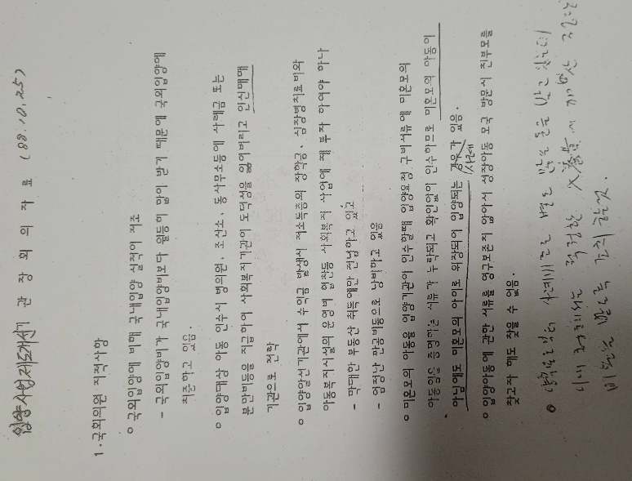
The documents have been handed over to South Korea's Truth and Reconciliation Commission, which is currently investigating adoptions from South Korea.

